**PATUAKHALI SCIENCE AND TECHNOLOGY UNIVERSITY**

**COURSE CODE CCE-224**

**SUBMITTED TO:**

### **Prof. Dr. Md Samsuzzaman**

### **Department of Computer and Communication Engineering**

**Faculty of Computer Science and Engineering**

**SUBMITTED BY:**

**Md. Sharafat Karim**

ID: **2102024**,

Registration No: **10151**

**Faculty of Computer Science and Engineering**

Date of submission: **06 Thu, 2025**

Assignment 03

Assignment title: ER diagrams

* University Management system

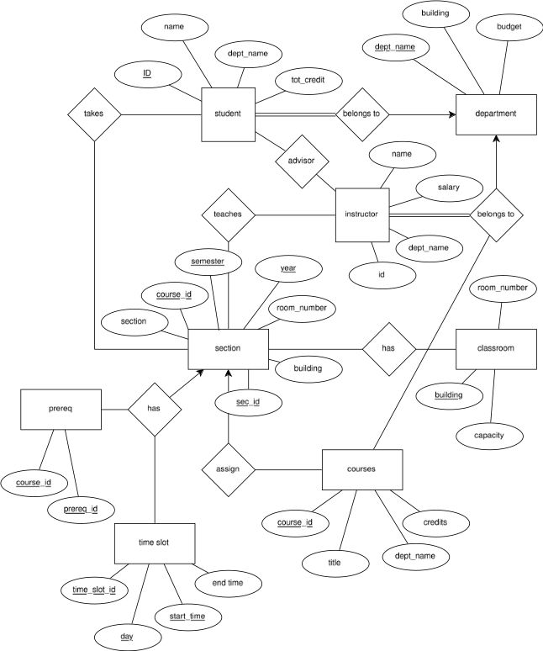

* ER Diagram of Hotel Management System

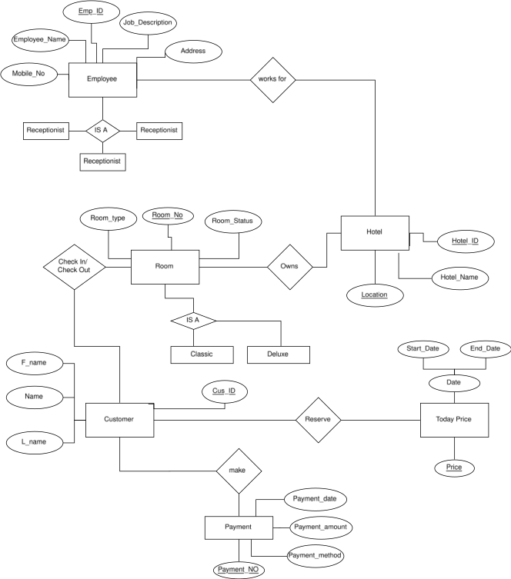

* ER Diagram of Library Management System

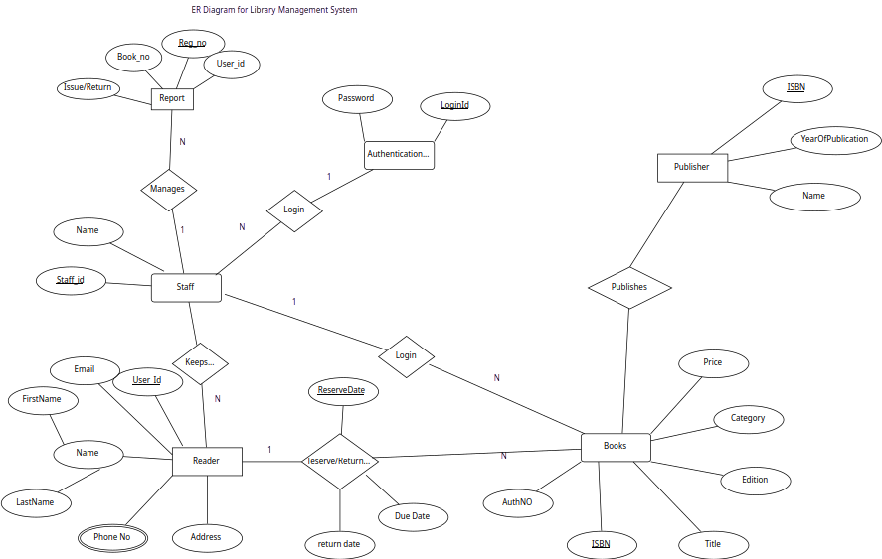

* ER Diagram of Online Shopping System

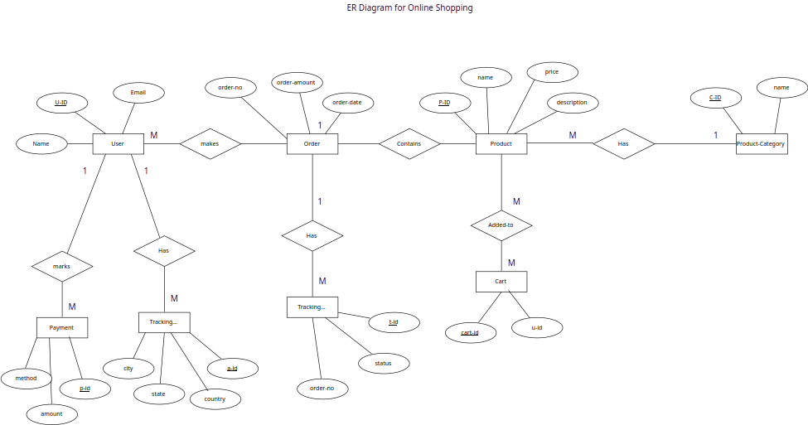

* ER Diagram of NoSQL Database

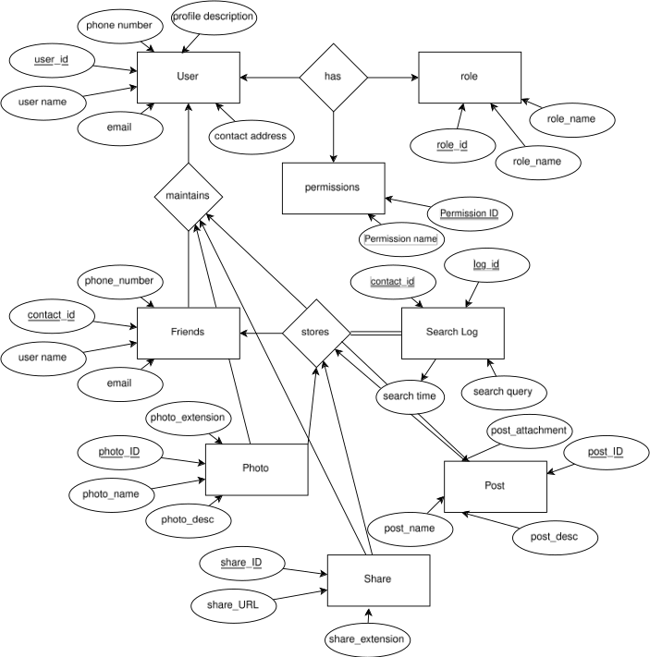

* ER Diagram of One-to-Many Relationship

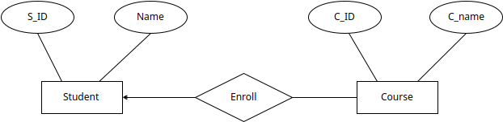

* ER Diagram of Banking System

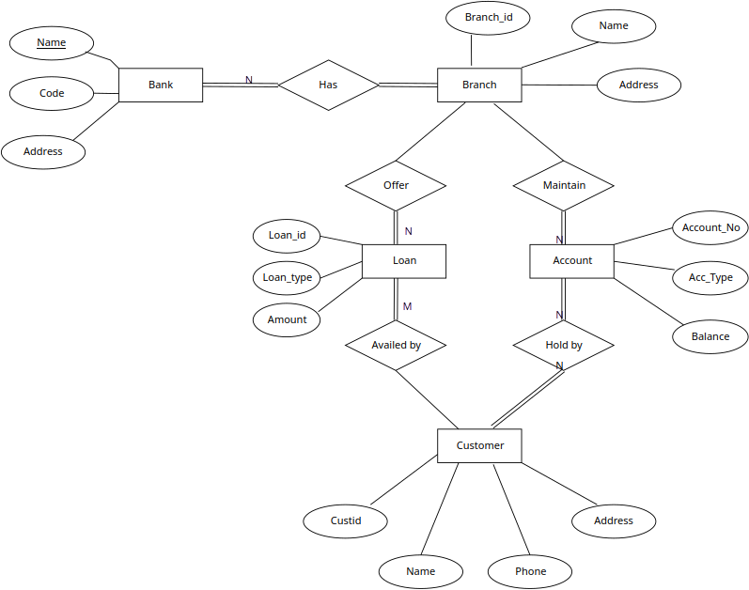

* ER Diagram of Hospital Management System

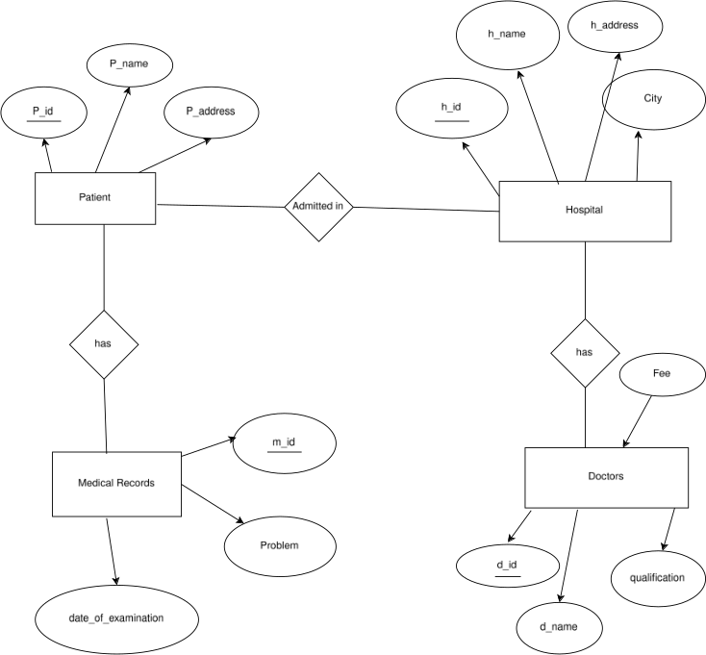

* Telephone directory Management system

